Organization Name:
Army Network System
Address:
PAKISTAN



Project Members:

- Malik Ehtsam Ali (21-Arid-590)

- Saqib Ali (21-Arid-666)

Organization Introduction:
The Army Network System is a vital component of modern military operations. It encompasses a range of interconnected technologies and communication systems that enable the efficient exchange of information, command, and control within the military. This report aims to provide an overview of the Army Network System, its key components, and the importance of its integration for effective military operations.

Tactical Communication Systems:

1.2. Network Infrastructure:
The network infrastructure comprises the hardware, software, and protocols necessary to establish and maintain connectivity among various military units. It includes routers, switches, servers, and encryption mechanisms to ensure secure and reliable data transmission across the network.

1.3. Command and Control Systems:
Command and control systems provide the means for commanders to monitor and direct military operations. These systems integrate data from multiple sources, such as surveillance equipment and intelligence reports, to create a comprehensive situational awareness picture. They enable commanders to make informed decisions and issue orders effectively.

Command and Control Systems

1.4. Cybersecurity Measures:
In an era of increasing cyber threats, robust cybersecurity measures are crucial for the Army Network System. Firewalls, intrusion detection systems, encryption techniques, and strict access controls are implemented to safeguard classified information, prevent unauthorized access, and mitigate cyber attacks that could compromise the network's integrity.
2. Importance of the Army Network System:

2.1. Enhanced Situational Awareness:
The Army Network System provides real-time situational awareness, allowing military personnel to gather, analyze, and disseminate critical information rapidly. This enables commanders to make well-informed decisions and enhances the effectiveness of military operations.

2.2. Improved Command and Control:
Efficient command and control systems facilitate effective coordination among military units, leading to improved synchronization and mission success. The Army Network System enables seamless communication and information sharing, allowing commanders to exercise greater control over their forces.

2.3. Rapid Information Exchange:
The Army Network System enables the rapid exchange of information between units, reducing the decision-making cycle and enhancing operational agility. Timely and accurate information sharing is crucial for maintaining operational tempo and responding swiftly to changing battlefield dynamics.

2.4. Enhanced Force Protection:
By integrating various surveillance and reconnaissance assets, the Army Network System enhances force protection capabilities. It enables the collection and analysis of intelligence data, early detection of threats, and efficient dissemination of warnings to deployed forces.

No Of Devices:
PCs : 45
Switches : 3
Router : 2
Server : 3 FTP,2 DHCP

PROBLEM:
Broadcasting, Not a properly stored file.
NETWORK MODEL:
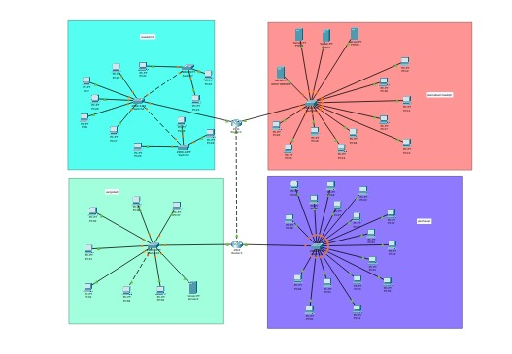

Proposed Network:
The purpose of Network is new serer is update .it is properly stored file in servers.Not a lose of data in server.

Main server :
Two DHCP server are provided IP all computer. And other three FTP server are stored files.
DHCP CONFIGURATION 1:
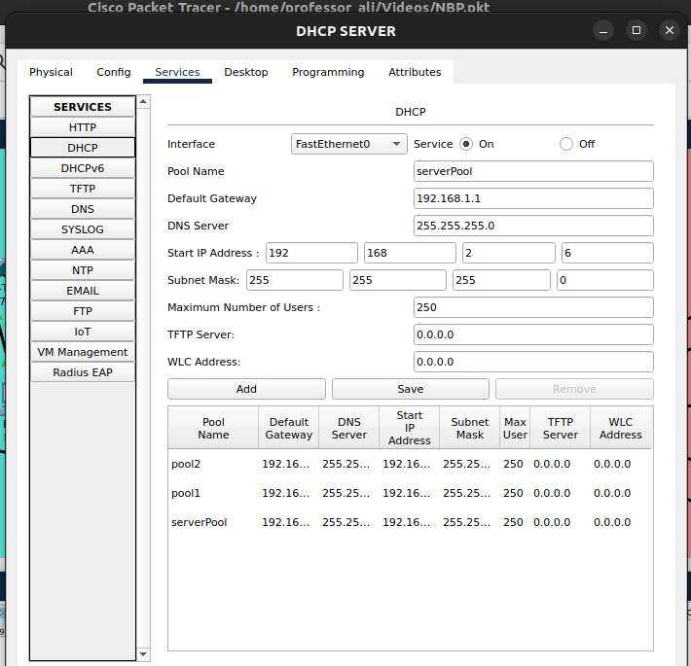

DHCP CONFIGURATION 2:
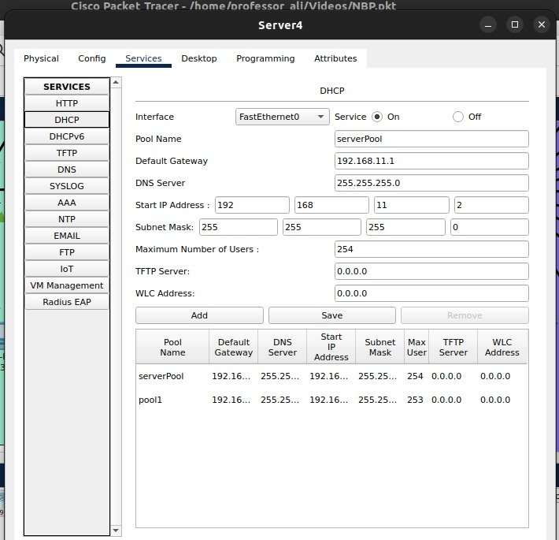
Router Configuration:
Router 1:
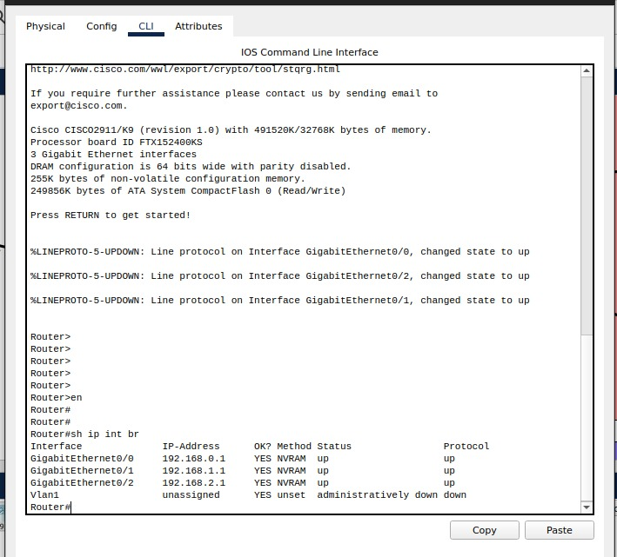
Router 2:

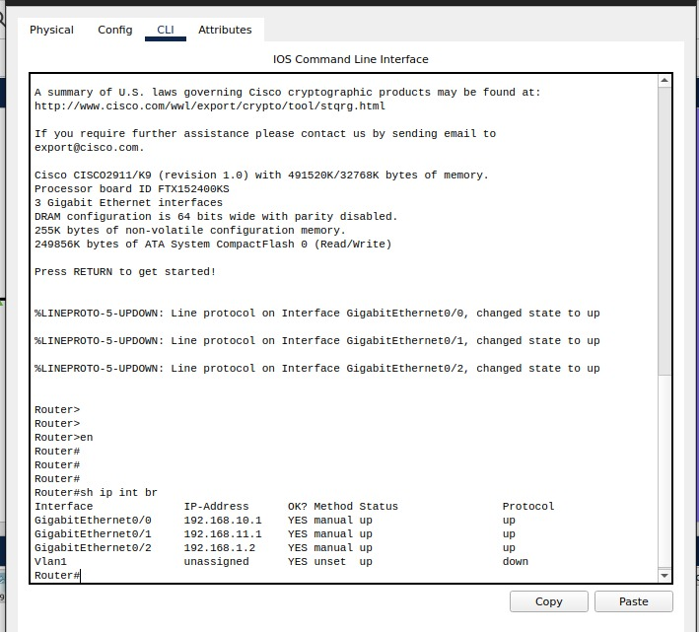
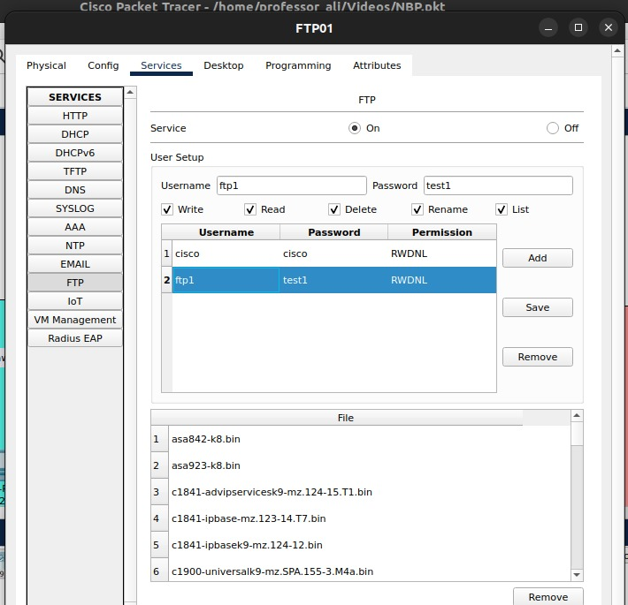

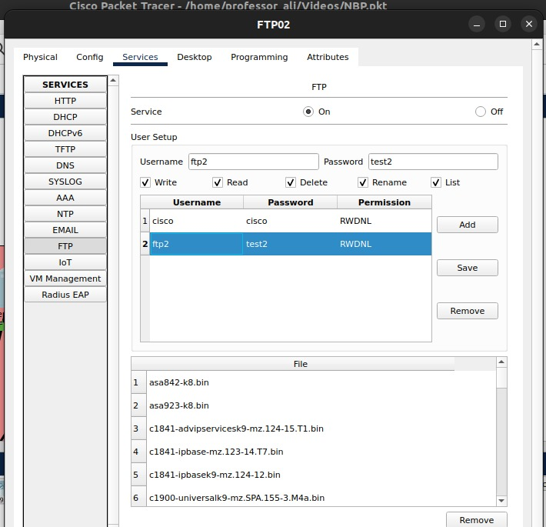
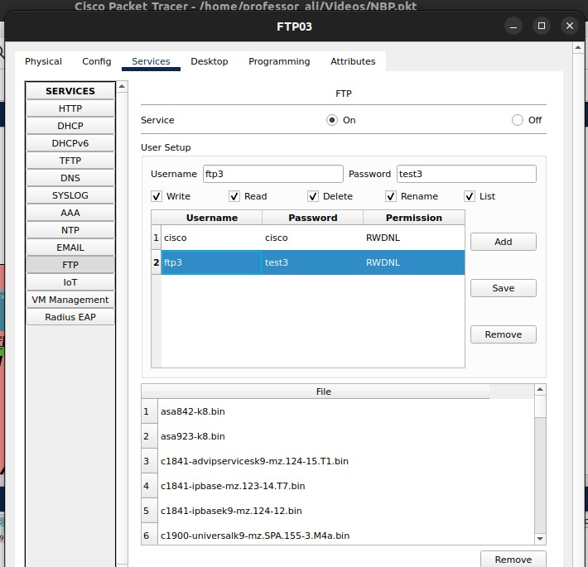

Conclusion:
The Army Network System plays a pivotal role in modern military operations by providing seamless communication, enhanced situational awareness, and improved command and control. Its components, including tactical communication systems, network infrastructure, command and control systems, and cybersecurity measures, work together to create a reliable and secure network environment. By leveraging these capabilities, the military can achieve greater operational effectiveness, better protect its personnel, and maintain an edge in the modern battlefield.

